# KLS: Buy signal in 17/02/2012, Price 9.5. HOLD

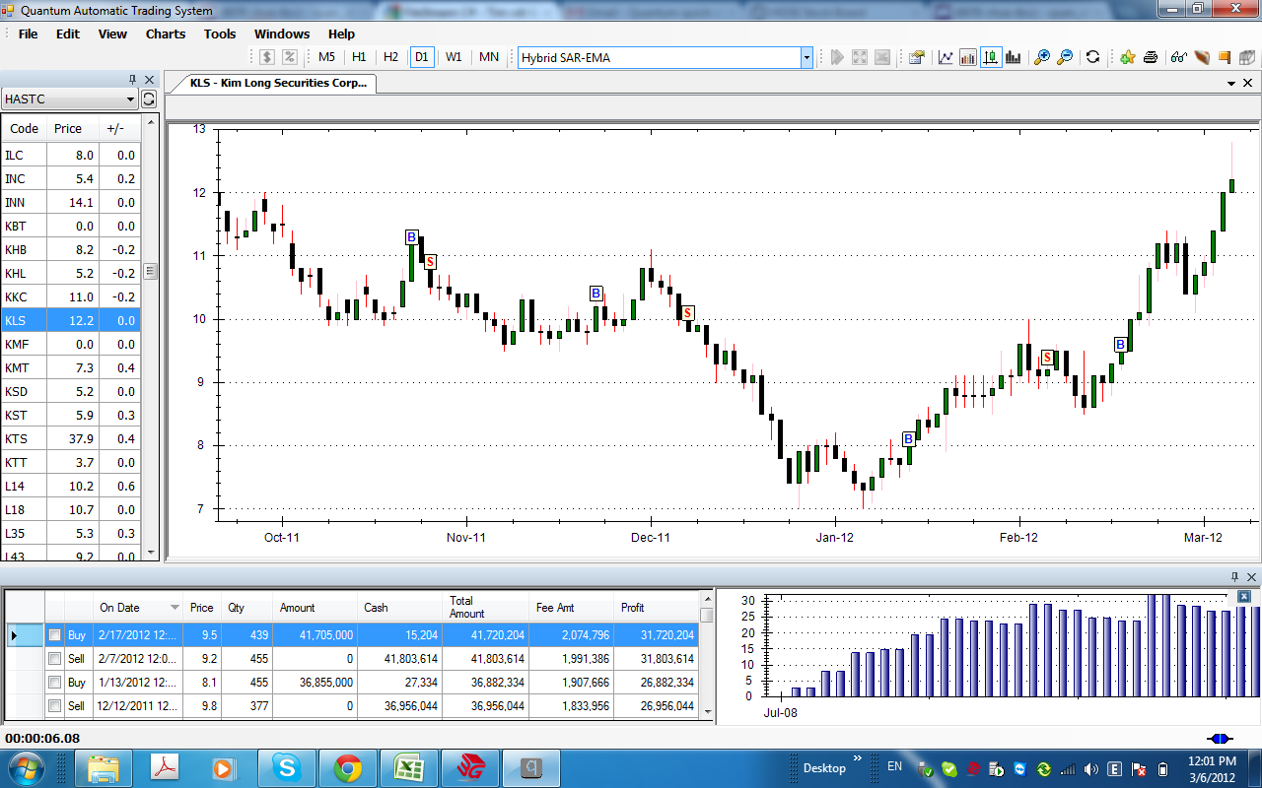

# DIG, Buy signal in 20/02/2012, Price 13.7, HOLD.

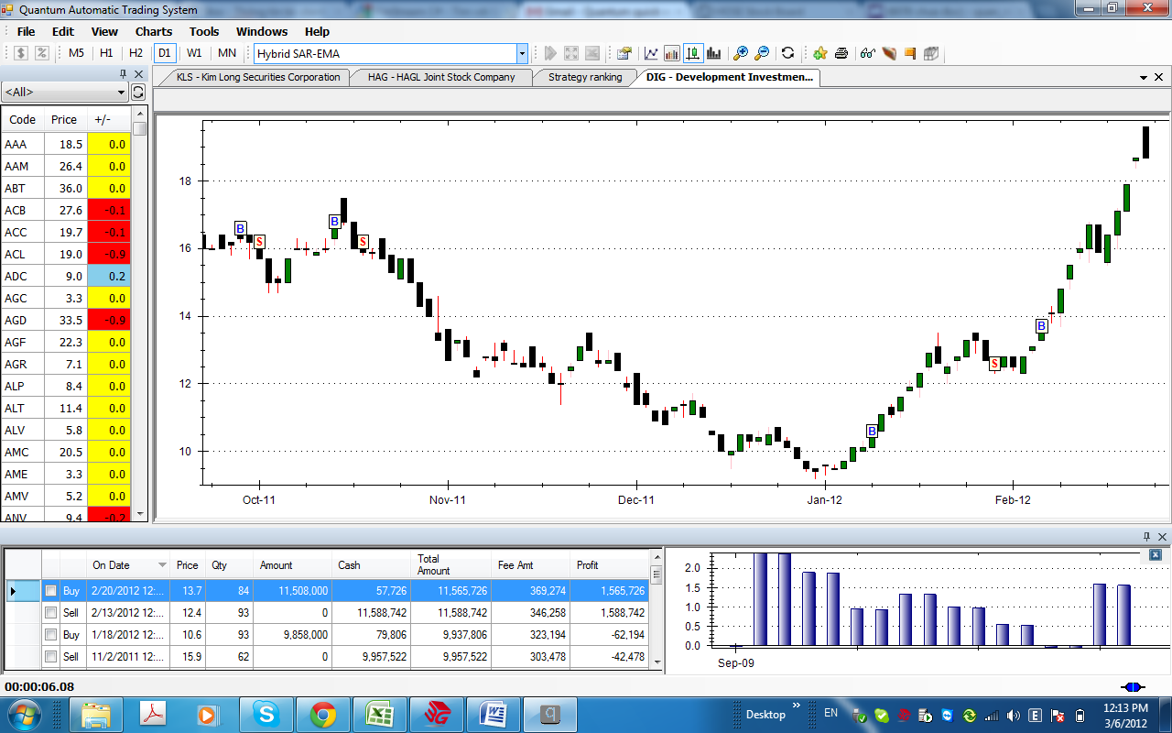

# HAG, Buy signal in 20/02,2012, Price 25. HOLD

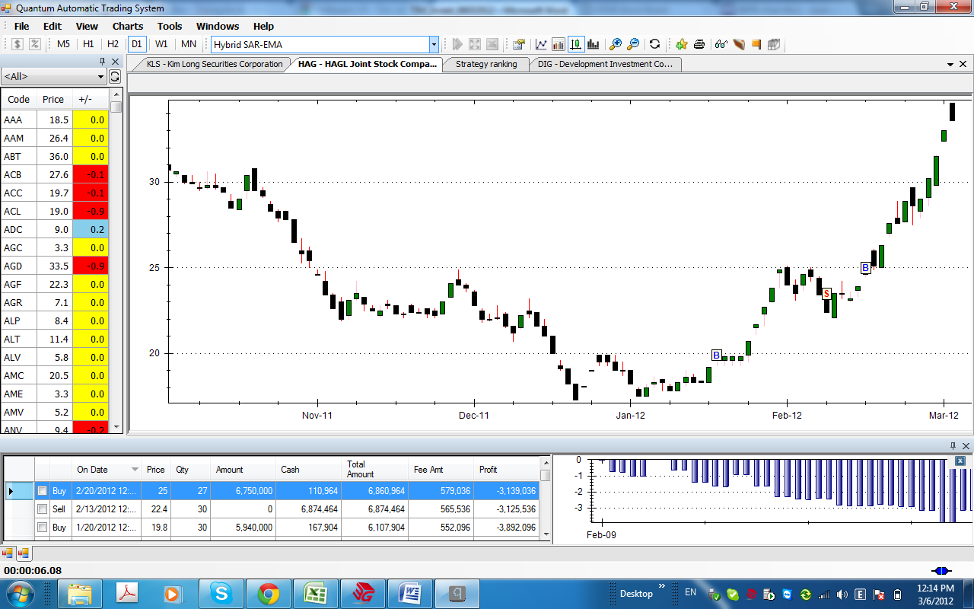

# HPG, Buy signal in 23/02/2012, HOLD

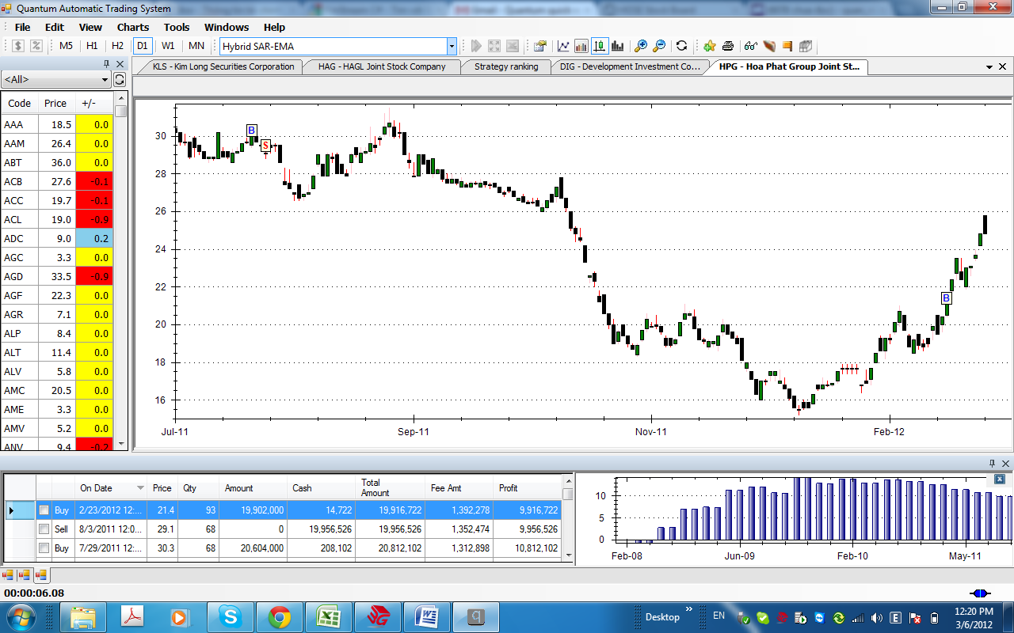

# VND, Buy signal in 02/03/2012, Price 9.6, HOLD

